2. Write a shell script that consists of a function that displays the number of files in the present working directory. Name this function “file_count” and call it in your script. If you use variable in your function, remember to make it a local variable.

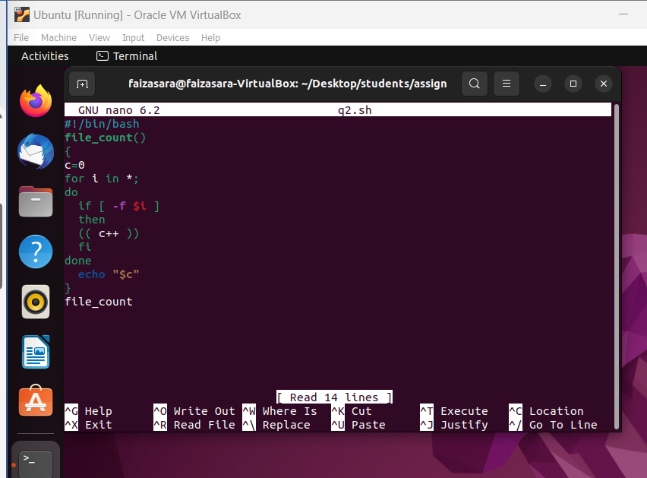

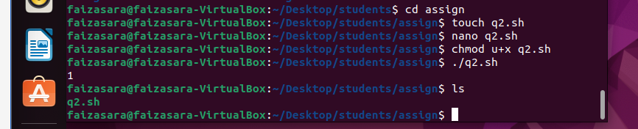

3.For each directory in the $PATH, display the number of executable in that directory

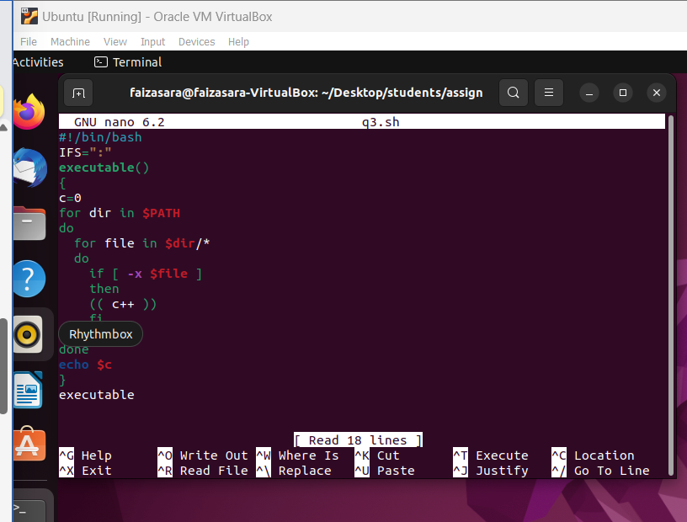

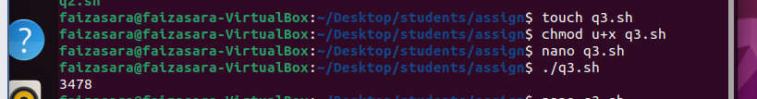

4.Display the names of any file-system which have less than 10% free space available

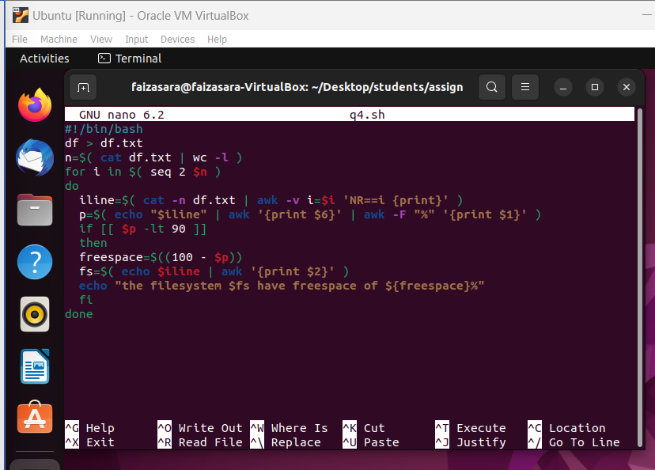

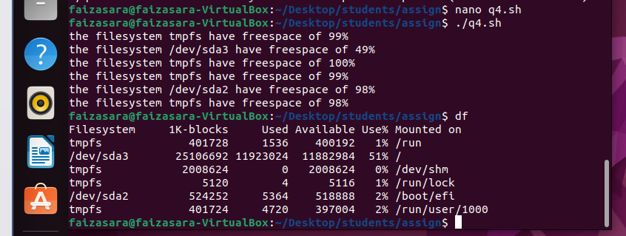

5. Write a script that takes any number of directories as command-line arguments and then lists the contents of each of these directories

